CRVS

Technical Documentation

Version 1.00

Revision History

Date | Version | Description | Author
2009-26-01 | 1.0 | Initial | Kiteplex IT

Table of Contents
1. Introduction 3
1.1 Purpose of this document 3
1.2 Intended Audience 3
1.3 Scope 3
2. General overview 3
2.1 General functioning 3
3. Detail explanation 3
3.1 Flow Diagram 4
3.2 Login 4
3.3 School list 5
3.4 Add new school 5
3.5 School Details 6
3.5.1 Edit Details 6
3.5.2 Teachers 6
3.5.3 Add new Teachers 6
3.5.4 Classes 7
3.5.5 Class Edit 7
3.5.6 Student detail edit 7
3.5.7 Add new students 8

Introduction

Purpose of this document

The purpose of this document is to give information about CRVS and how to use the school management system.

Intended Audience

The intended audiences are:
- Teachers, to analyze the design and implementation of CRVS.
- CRVS team members.
- Future developers to extend or use some ideas of CRVS project.

Scope

This document will describe the design and some technical issues of CRVS project.

General overview

General functioning

The following are the major system functionalities:
- Register user in CRVS web site
- Load the School lists
- User can create a new School Deffination
- Select a school to view the school-details page
- On the Edit School sub-tab user can edit school details
- Teachers sub-tab shows the full list of corresponding school
- Classes sub-tab contains all corresponding class list and complete list of students for each class
- Existing student’s details can be edited through Edit Student form
- New students can be created for the selected school by pressing the New button

Detail explanation

Flow Diagram
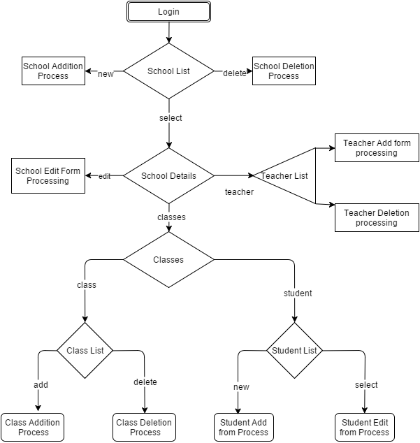

Login

The following image shows the login window.

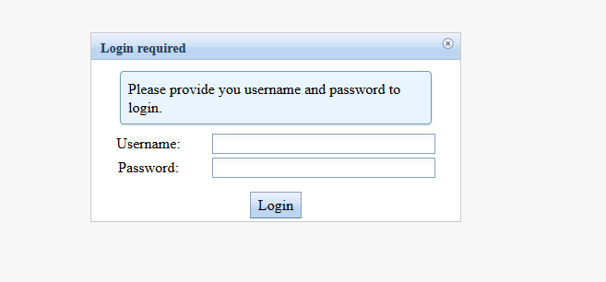
Figure 1: Login window

School List
Figure 2: Login window

Add New School
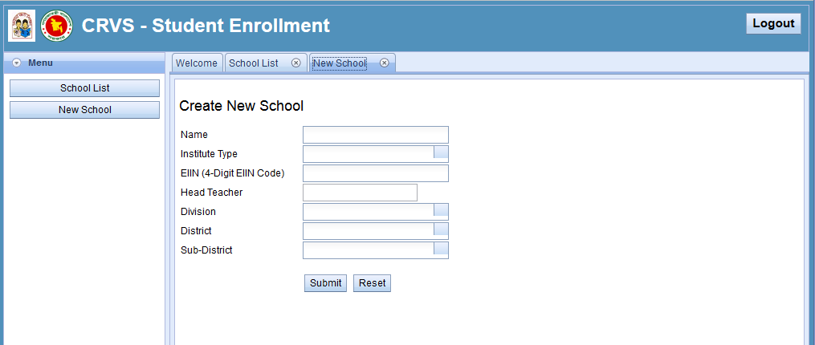
Figure 3: New School creation

School Details

Edit School
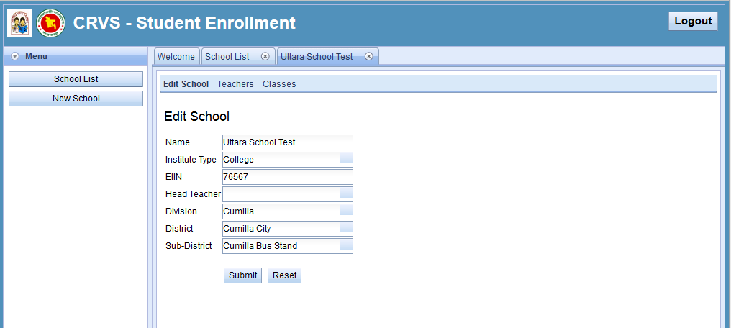
Figure 4: Edit school

Teachers
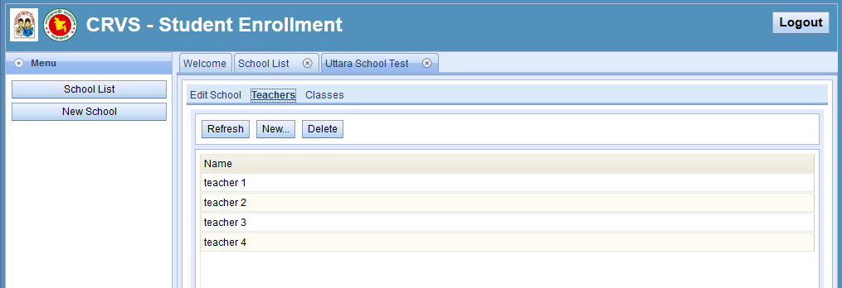
Figure 5: Teacher list

Add new teacher
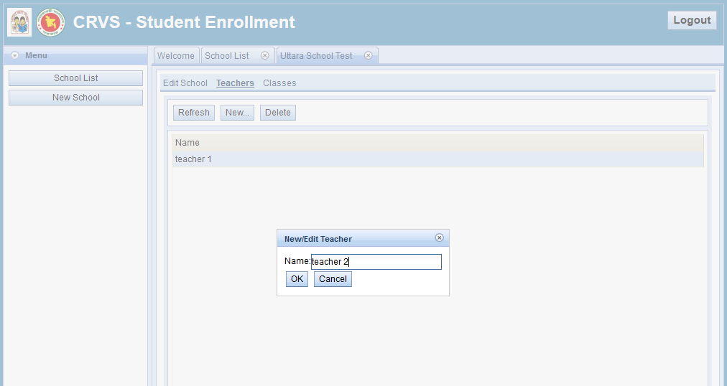
Figure 6: Add new teacher

Classes
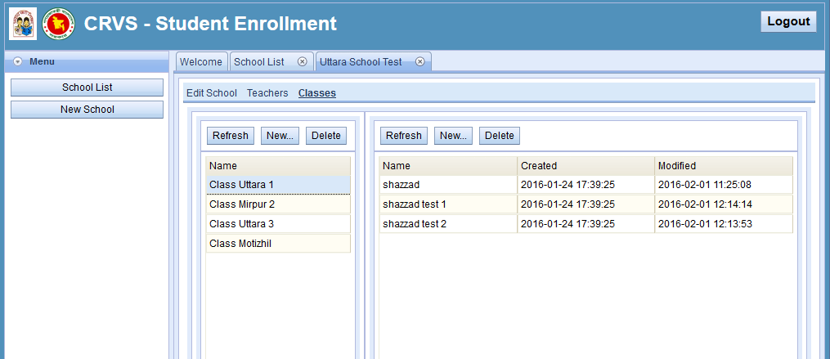
Figure 7: class details page

Class Edit
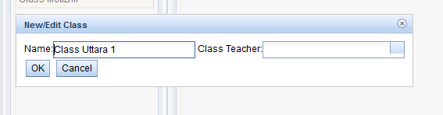
Figure 8: class edit

Student detail edit
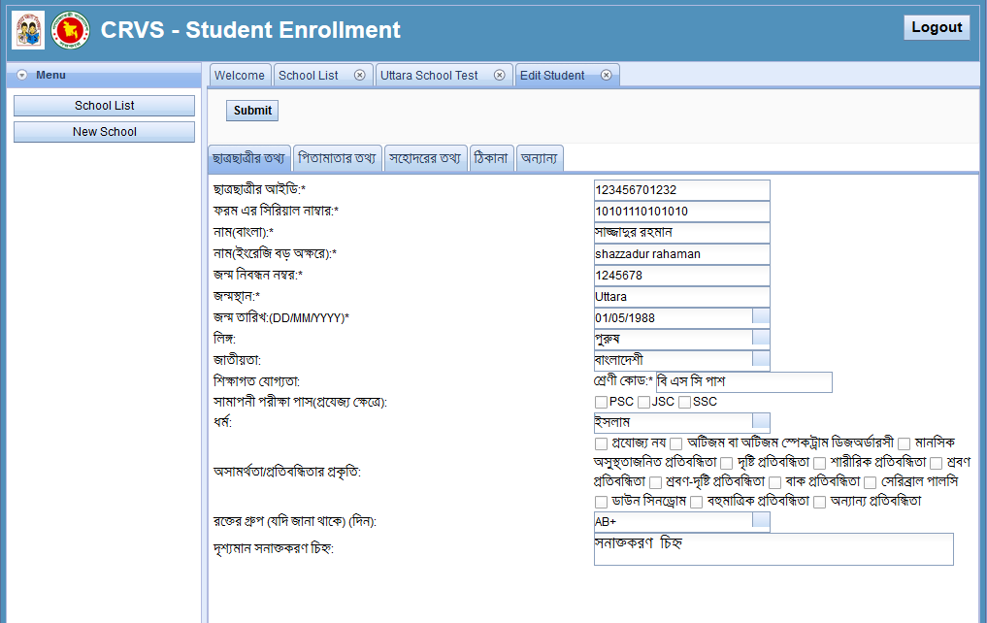
Figure 9: student detail edit form

Add new students
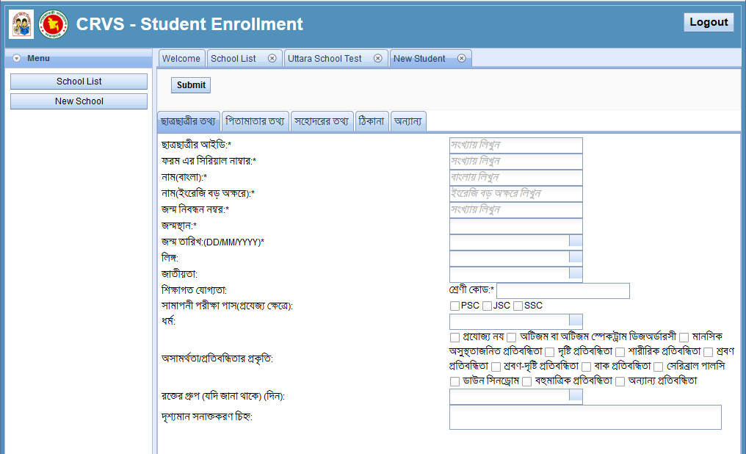
Figure 10: add new student form

